**REPORT**

**Design and Simulation**

1. **Instantiating and Connecting PEs**

**Requirement:**

//FILL IN REST OF THE CODE (x)

//Three of them are connected below. Connect the others properly.

processing_element pe00(.reset(effective_rst), .clk(clk), .in_a(a0), .in_b(b0), .out_a(a00to01), .out_b(b00to10), .out_c(matrixC00));

processing_element pe01(.reset(effective_rst), .clk(clk), .in_a(a00to01), .in_b(b1), .out_a(a01to02), .out_b(b01to11), .out_c(matrixC01));

processing_element pe02(x);

processing_element pe03(x);

processing_element pe10(.reset(effective_rst), .clk(clk), .in_a(a1), .in_b(b00to10), .out_a(a10to11), .out_b(b10to20), .out_c(matrixC10));

processing_element pe11(x);

processing_element pe12(x);

processing_element pe13(x);

processing_element pe20(x);

processing_element pe21(x);

processing_element pe22(x);

processing_element pe23(x);

processing_element pe30(x);

processing_element pe31(x);

processing_element pe32(x);

processing_element pe33(x);

**Solution:**

There are 3 inputs and 3 outputs from Processing Element (PEs). Two inputs from Matrix A and Matrix B will be given to PE and again through FF will be given to another processing element. Multiplication and accumulative result (c+ab) will be store in Matrix varirable.

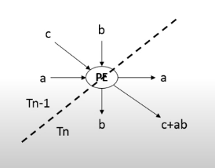

**Output Code:**

These are the remaining PEs in order to perform a 4 x 4 matmul.

//FILL IN REST OF THE CODE (x)

processing_element pe00(.reset(effective_rst), .clk(clk), .in_a(a0), .in_b(b0), .out_a(a00to01), .out_b(b00to10), .out_c(matrixC00));

processing_element pe10(.reset(effective_rst), .clk(clk), .in_a(a00to01), .in_b(b1), .out_a(a10to11), .out_b(b10to20), .out_c(matrixC10));

processing_element pe20(.reset(effective_rst), .clk(clk), .in_a(a10to11), .in_b(b2), .out_a(a20to21), .out_b(b20to30), .out_c(matrixC20));

processing_element pe30(.reset(effective_rst), .clk(clk), .in_a(a20to21), .in_b(b3), .out_a(a30to31), .out_b(b30to40), .out_c(matrixC30));

processing_element pe01(.reset(effective_rst), .clk(clk), .in_a(a1), .in_b(b00to10), .out_a(a01to02), .out_b(b01to11), .out_c(matrixC01));

processing_element pe11(.reset(effective_rst), .clk(clk), .in_a(a01to02), .in_b(b10to20), .out_a(a11to12), .out_b(b11to21), .out_c(matrixC11));

processing_element pe21(.reset(effective_rst), .clk(clk), .in_a(a11to12), .in_b(b20to30), .out_a(a21to22), .out_b(b21to31), .out_c(matrixC21));

processing_element pe31(.reset(effective_rst), .clk(clk), .in_a(a21to22), .in_b(b30to40), .out_a(a31to32), .out_b(b31to41), .out_c(matrixC31));

processing_element pe02(.reset(effective_rst), .clk(clk), .in_a(a2), .in_b(b01to11), .out_a(a02to03), .out_b(b02to12), .out_c(matrixC02));

processing_element pe12(.reset(effective_rst), .clk(clk), .in_a(a02to03), .in_b(b11to21), .out_a(a12to13), .out_b(b12to22), .out_c(matrixC12));

processing_element pe22(.reset(effective_rst), .clk(clk), .in_a(a12to13), .in_b(b21to31), .out_a(a22to23), .out_b(b22to32), .out_c(matrixC22));

processing_element pe32(.reset(effective_rst), .clk(clk), .in_a(a22to23), .in_b(b31to41), .out_a(a32to33), .out_b(b32to42), .out_c(matrixC32));

processing_element pe03(.reset(effective_rst), .clk(clk), .in_a(a3), .in_b(b02to12), .out_a(a03to04), .out_b(b03to13), .out_c(matrixC03));

processing_element pe13(.reset(effective_rst), .clk(clk), .in_a(a03to04), .in_b(b12to22), .out_a(a13to14), .out_b(b13to23), .out_c(matrixC13));

processing_element pe23(.reset(effective_rst), .clk(clk), .in_a(a13to14), .in_b(b22to32), .out_a(a23to24), .out_b(b23to33), .out_c(matrixC23));

processing_element pe33(.reset(effective_rst), .clk(clk), .in_a(a23to24), .in_b(b32to42), .out_a(a33to34), .out_b(b33to43), .out_c(matrixC33));

1. **# of Clock Cycles Needed for matmul**

**Requirement:**

//FILL IN THE CODE (x)

assign cycles_for_matmul = 8'dx;

**Solution:**

cycles_for_matmul = 8'd14;  
On assigning 8’d14 value, it has exactly N*N values populated.

**Verification using waveform:**

As we know,if the count is too low, matrix C will not be fully filled and also if the count is too high, matrix C will be overfilled with 0’s. It is fully filled with assign cycles_for_matmul = 8'd14;

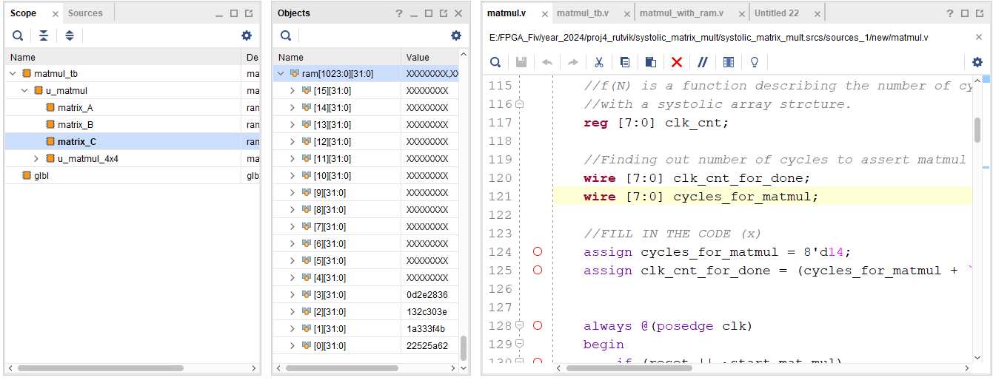

1. **Instantiating Block RAMs**

**Requirement:**

//FILL IN THE CODE (x)

////////////////////////////////////////////////////////////////

// BRAM matrix A

////////////////////////////////////////////////////////////////

ram matrix_A (x);

////////////////////////////////////////////////////////////////

// BRAM matrix B

////////////////////////////////////////////////////////////////

ram matrix_B (x);

////////////////////////////////////////////////////////////////

// BRAM matrix C

////////////////////////////////////////////////////////////////

ram matrix_C (x);

**Solution:**

////////////////////////////////////////////////////////////////

// BRAM matrix A

////////////////////////////////////////////////////////////////

ram matrix_A (

.addr0(bram_addr_a), // Address input connected to port 0

.d0(bram_wdata_a), // Data input connected to port 0

.we0(bram_we_a), // Write enable input connected to port 0

.q0(bram_rdata_a), // Data output connected to port 0

.addr1(bram_addr_a_ext), // Address input connected to port 1 (external)

.d1(bram_wdata_a_ext), // Data input connected to port 1 (external)

.we1(bram_we_a_ext), // Write enable input connected to port 1 (external)

.q1(bram_rdata_a_ext), // Data output connected to port 1 (external)

.clk(clk) // Clock input

);

////////////////////////////////////////////////////////////////

// BRAM matrix B

////////////////////////////////////////////////////////////////

ram matrix_B (

.addr0(bram_addr_b), // Address input connected to port 0

.d0(bram_wdata_b), // Data input connected to port 0

.we0(bram_we_b), // Write enable input connected to port 0

.q0(bram_rdata_b), // Data output connected to port 0

.addr1(bram_addr_b_ext), // Address input connected to port 1 (external)

.d1(bram_wdata_b_ext), // Data input connected to port 1 (external)

.we1(bram_we_b_ext), // Write enable input connected to port 1 (external)

.q1(bram_rdata_b_ext), // Data output connected to port 1 (external)

.clk(clk) // Clock input

);

////////////////////////////////////////////////////////////////

// BRAM matrix C

////////////////////////////////////////////////////////////////

ram matrix_C (

.addr0(bram_addr_c), // Address input connected to port 0

.d0(bram_wdata_c), // Data input connected to port 0

.we0(bram_we_c), // Write enable input connected to port 0

.q0(bram_rdata_c), // Data output connected to port 0

.addr1(bram_addr_c_ext), // Address input connected to port 1 (external)

.d1(bram_wdata_c_ext), // Data input connected to port 1 (external)

.we1(bram_we_c_ext), // Write enable input connected to port 1 (external)

.q1(bram_rdata_c_ext), // Data output connected to port 1 (external)

.clk(clk) // Clock input

);

**Verification using waveform:**

Matrix_A: Data stored in ram is equal to data in test case

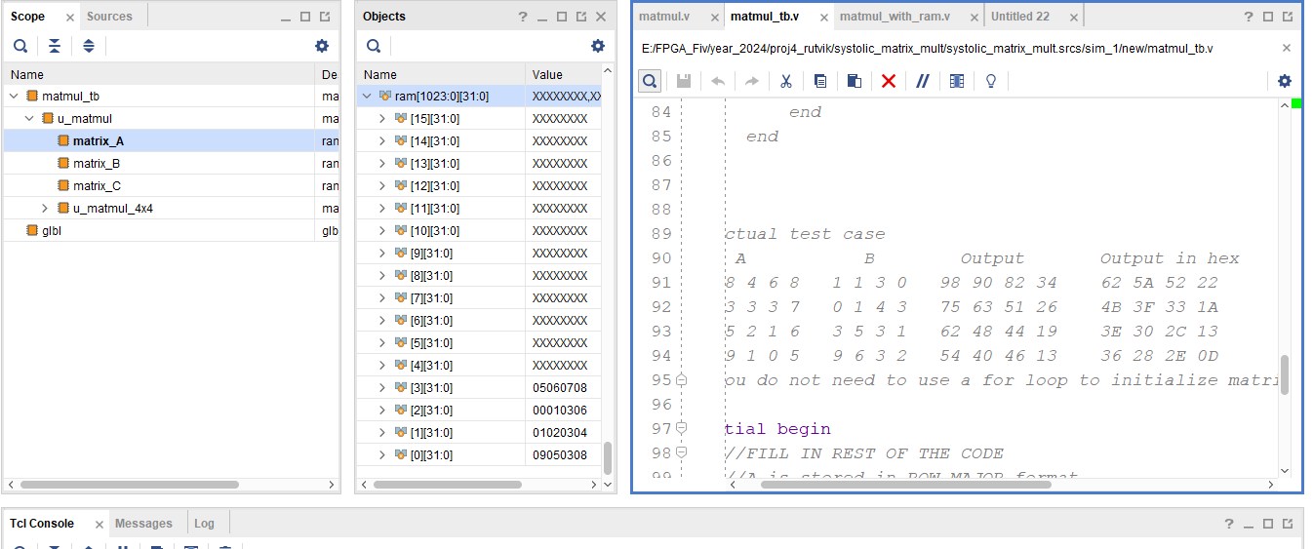

Matrix_B: Data stored in ram is equal to data in test case

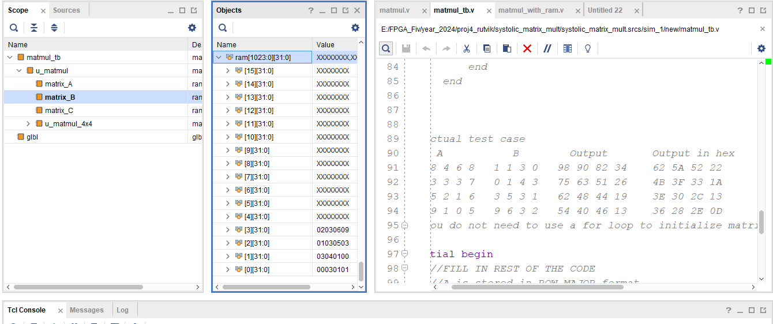

Matrix_C: Data stored in ram is equal to data in test case

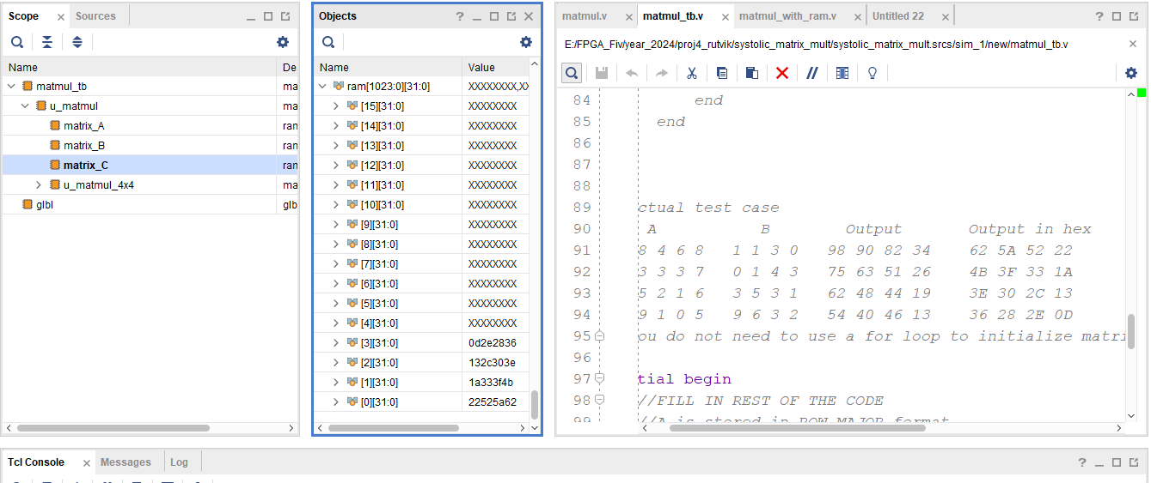

1. **More Testcases in Testbench**

**Test Case 1:**

Test bench code:

integer i;

initial

begin

for (i=0; i<4; i = i + 1)

begin

u_matmul.matrix_A.ram[i] = {8'h01, 8'h01, 8'h01, 8'h01};

u_matmul.matrix_B.ram[i] = {8'h01, 8'h01, 8'h01, 8'h01};

end

end

**Verification using waveform:**

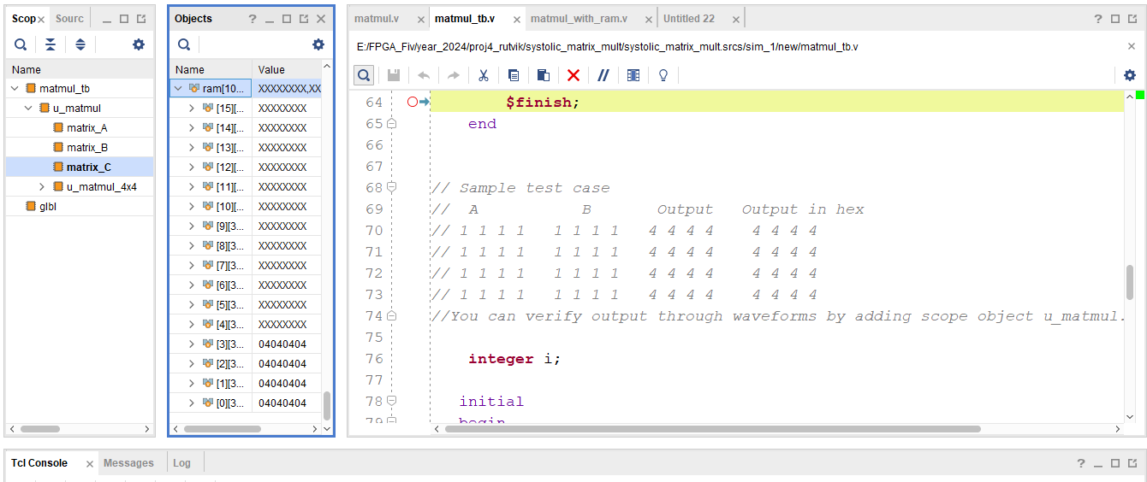

**Test Case 2:**

Test bench code:

initial begin

u_matmul.matrix_A.ram[0] = {8'h09, 8'h05, 8'h03, 8'h08};

u_matmul.matrix_A.ram[1] = {8'h01, 8'h02, 8'h03, 8'h04};

u_matmul.matrix_A.ram[2] = {8'h00, 8'h01, 8'h03, 8'h06};

u_matmul.matrix_A.ram[3] = {8'h05, 8'h06, 8'h07, 8'h08};

u_matmul.matrix_B.ram[0] = {8'h00, 8'h03, 8'h01, 8'h01};

u_matmul.matrix_B.ram[1] = {8'h03, 8'h04, 8'h01, 8'h00};

u_matmul.matrix_B.ram[2] = {8'h01, 8'h03, 8'h05, 8'h03};

u_matmul.matrix_B.ram[3] = {8'h02, 8'h03, 8'h06, 8'h09};

end

**Verification using waveform:**

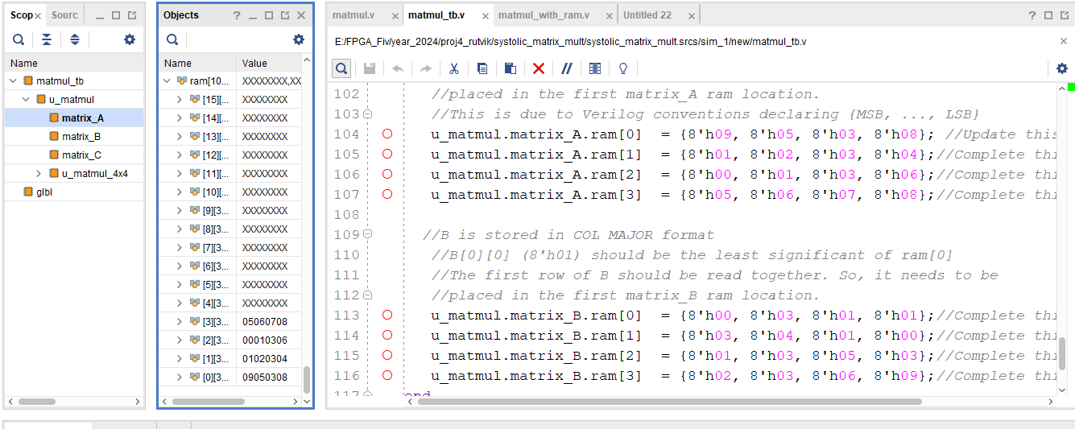

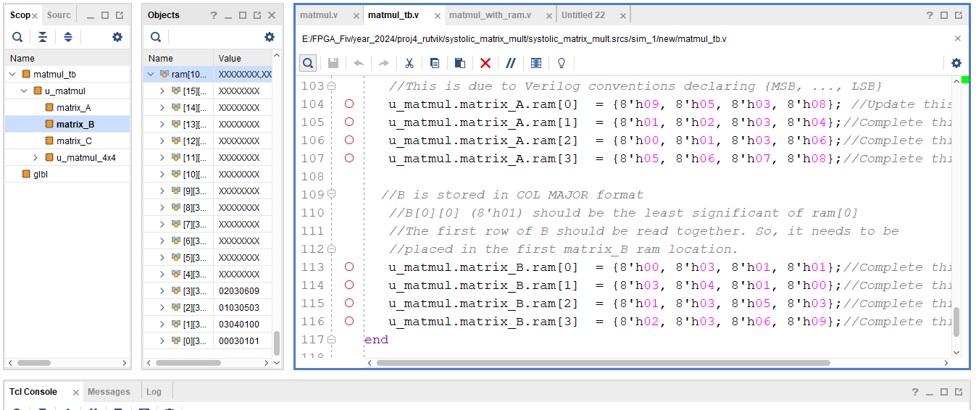

1. **Simulation**

Add the following signals from the scope to the wave window:

* u_matmul.matrix_C.ram[7:0][31:0]
* u_matmul.u_matmul_4x4.a_data[31:0]
* u_matmul.u_matmul_4x4.b_data[31:0]
* u_matmul.u_matmul_4x4.c_data_out[31:0]
* u_matmul.u_matmul_4x4.reset
* u_matmul.u_matmul_4x4.clk_cnt[7:0]

**For Test Case 1:**

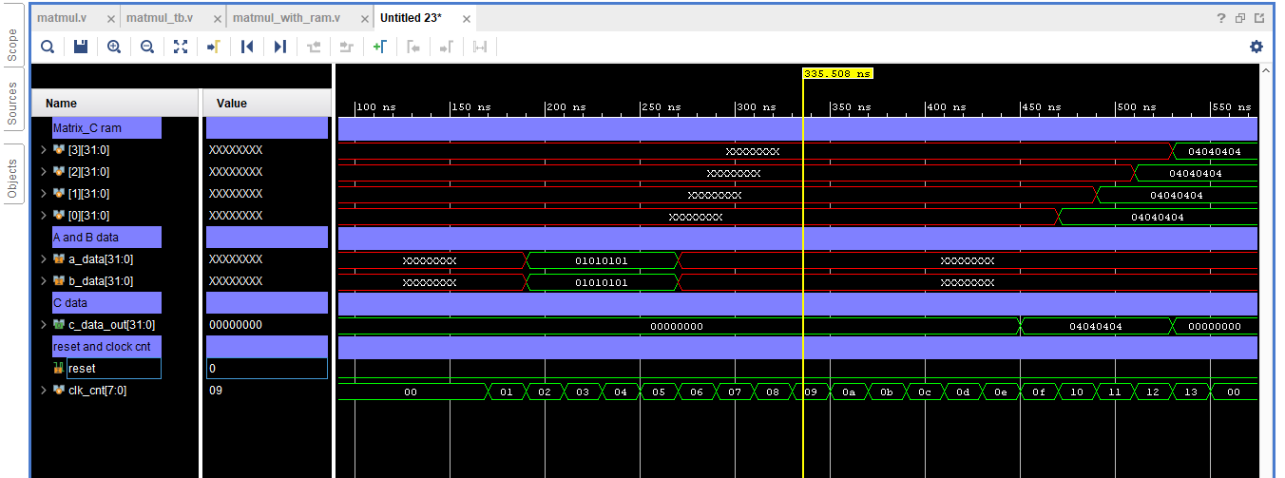

**For Test Case 2:**

